**NAME:** Salunke Shriram Hemant

**C Practice Assignments:**

1. Find total and percentage of marks.

**CODE:**

# include <stdio.h>

int main ( )

{

float eng., phy, chem, math, comp ;

float total, average, percentage;

printf("Enter marks of five subjects: \n");

scanf("%f%f%f%f%f", &eng, &phy, &chem, &math, &comp);

total = eng + phy + chem + math + comp;

average = total / 5.0;

percentage = (total / 500.0) * 100;

printf("Total marks = %.2f\n", total);

printf("Percentage = %.2f", percentage);

return 0;

}

**OUTPUT:**

Enter marks of subjects:

96

88

85

90

89

Total marks = 448.00

Percentage = 89.60

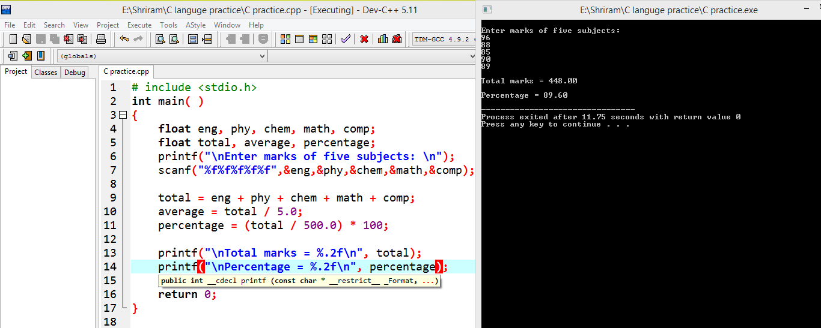

1. WAP to find D.A, HRA & gross salary if basic salary is input.

**CODE:**

#include <stdio.h>

int main ( )

{

float bs, hra, da, gs;

printf("\nEnter basic salary\n");

scanf("%f", &bs);

hra = bs * (20/100.00);

da = bs * (40/100.00);

gs = bs + hra + da;

printf("\n HRA = %f\n",hra);

printf("\n DA = %f\n",da);

printf("\n Gross Salary = %f\n", gs);

return 0;

}

**OUTPUT:**

Enter basic salary

15000

HRA = **3000.**000000

DA = 6000.000000

Gross Salary = **24000.**000000

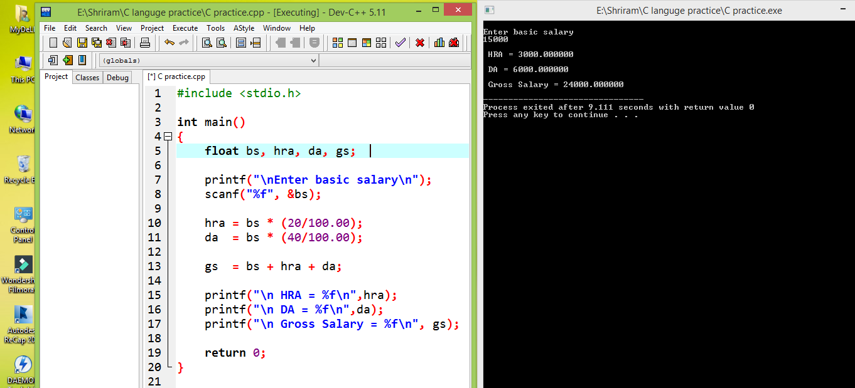

1. WAP to find area and perimeter of a rectangle.

**CODE:**

#include<stdio.h>

int main ( )

{

int length, breadth, area, perimeter;

printf("\nEnter the Length of Rectangle: ");

scanf("%d", &length);

printf("\nEnter the Breadth of Rectangle : ");

scanf("%d", &breadth);

area = length * breadth;

perimeter=2*(length+breadth);

printf("\nArea of Rectangle: %d", area);

printf("\nPerimeter of Rectangle : %d", perimeter);

return 0;

}

**OUTPUT:**

Enter length of rectangle: 15

Enter breadth of rectangle: 10

Area of Rectangle: 150

Perimeter of Rectangle: 50

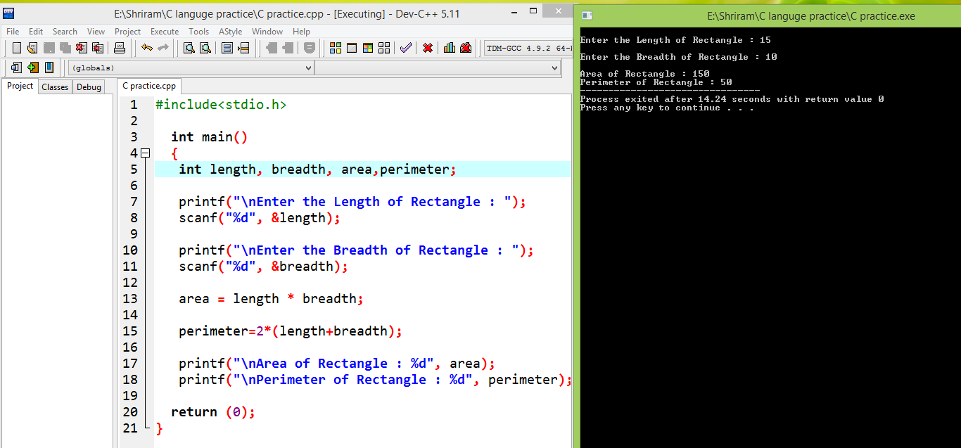

**4.** WAP to find whether the year is leap year or not.

**CODE:**

#include <stdio.h>

int main ( ) {

int year;

printf("\nEnter a year:\n ");

scanf("%d", &year);

if (year % 400 == 0) {

printf("\n%d is a leap year.\n", year);

else if (year % 100 == 0) {

printf("\n%d is not a leap year.\n", year); }

else if (year % 4 == 0) {

printf("\n%d is a leap year.\n", year);

else {

printf("\n%d is not a leap year.\n", year); }

return 0; }

**OUTPUT:**

Enter a year: 2020

2020 is a leap year.

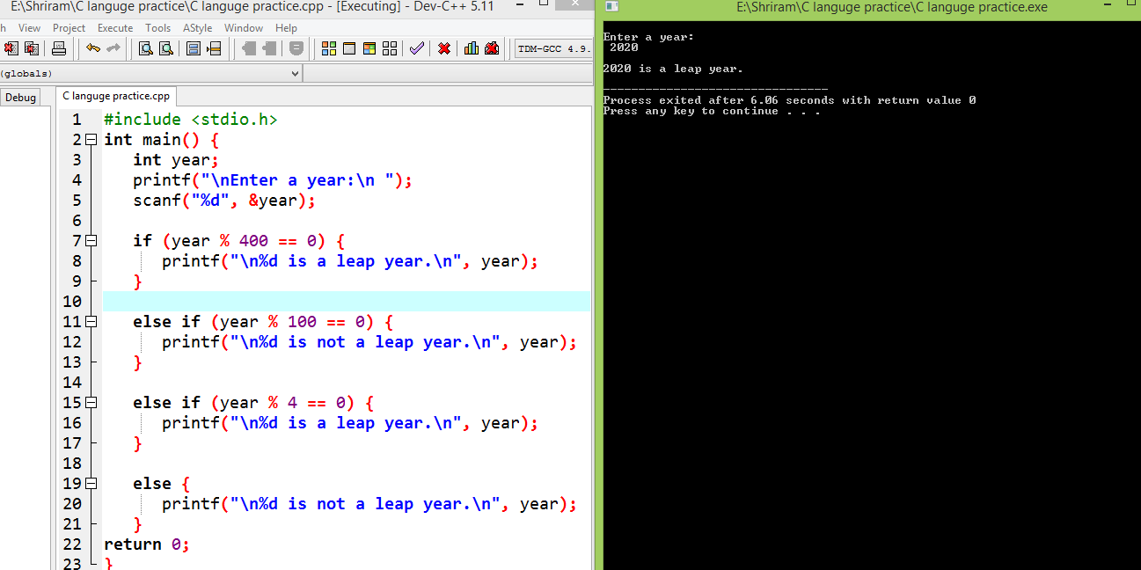

**5.** WAP to find the type of the triangle (equilateral, isosceles, right angled, scalene

**CODE:**

#include <stdio.h>

int main( ) {

int side1, side2, side3;

printf("Enter three sides of triangle:\n ");

scanf("%d%d%d", &side1, &side2, &side3);

if(side1==side2 && side2==side3)

{ printf("\nEquilateral triangle.\n"); }

else if(side1==side2 || side1==side3 || side2==side3)

{ printf("\nIsosceles triangle.\n"); }

else

{ printf("\nScalene triangle.\n"); }

return 0; }

**OUTPUT:** Enter three sides of triangle:

25

25

25

Equilateral Triangle

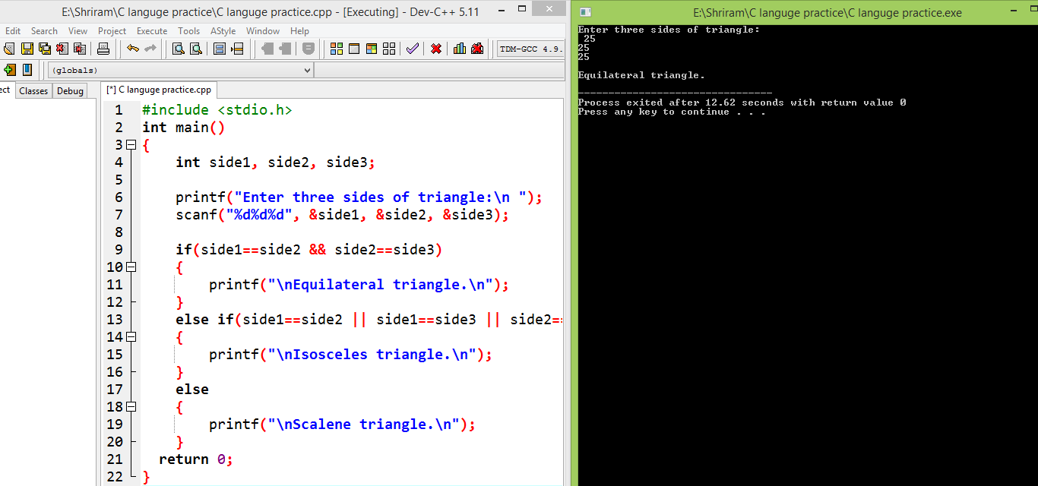

**6.** WAP to perform calculator operations (using switch-case).

#include<stdio.h>

int main( )

{ int choice;

long num1, num2, x;

printf("Please choose your option:"

"\n1 = Addition"

"\n2 = Subtraction"

"\n3 = Multiplication"

"\n4 = Division"

"\n5 = Squares"

"\n6 = exit"

"\n\nChoice: ");

scanf("%d", &choice);

while(choice < 1 || choice > 6)

{ printf("\n Please choose the above mentioned option."

"\nChoice: ");

scanf("%d", &choice); }

**switch (choice)**

{ **Case 1:**

printf("Enter two numbers: \n");

scanf("%ld %ld", &num1, &num2);

x = num1 + num2;

printf("Sum = %ld", x);

break;

**case 2:** printf("Enter two numbers: \n");

scanf("%ld %ld", &num1, &num2);

x = num1 - num2;

printf("Subtraction = %ld", x);

break;

**case 3:** printf("Enter two numbers: \n");

scanf("%ld %ld", &num1, &num2);

x = num1 * num2;

printf("Product = %ld", x);

break;

**case 4:** printf("Enter Dividend: ");

scanf("%d", &num1);

printf("Enter Divisor: ");

scanf("%d", &num2);

while(num2 == 0)

{

printf("\nDivisor cannot be zero."

"\nEnter divisor once again: ");

scanf("%d", &num2); }

x = num1 / num2;

printf("\nQuotient = %ld", x);

break;

**case 5:** printf("Enter any number: \n");

scanf("%ld", &num1);

x = num1 * num1;

printf("Square = %ld", x);

break;

return 0;

default: printf ("\nError");

} }

**OUTPUT:**

Please choice your option:

1 = Addition

2 = Subtraction

3 = Multiplication

4 = Division

5 = Squares

6 = Exit

**Choice: 1**

Enter the two numbers:

45

46

Sum = 91

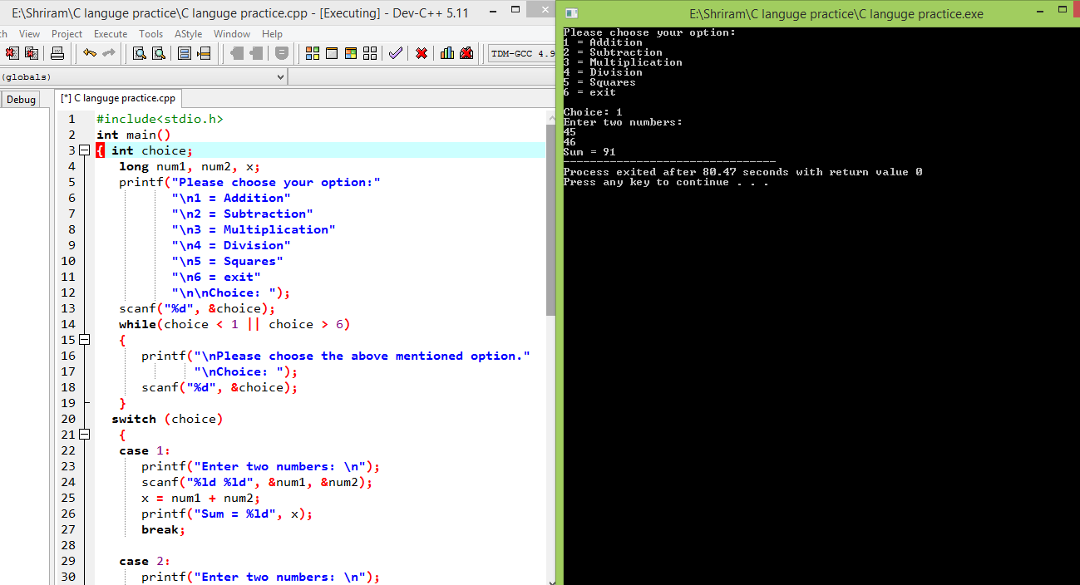

7. WAP to find factorial of a number.

**CODE:**

#include<stdio.h>

long int multiply Numbers(int n);

int main () {

int n;

printf("\n Enter a positive integer:\n ");

scanf("%d", &n);

printf("\n Factorial of %d = %ld\n", n, multiply Numbers(n));

return 0;

} long int multiply Numbers (int n) {

if (n>=1)

return n*multiply Numbers (n-1);

else

return 1;

}

**OUTPUT:**

Enter a positive integer:

4

Factorial of 4 = 24

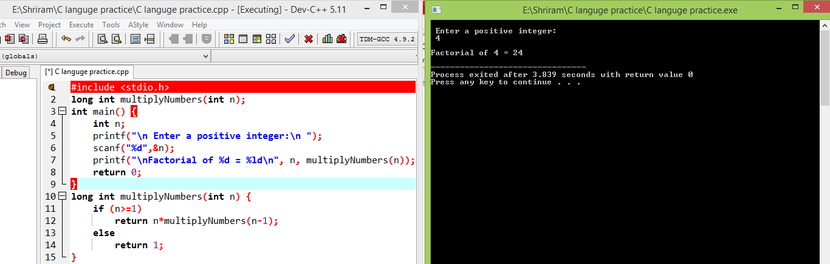

8. WAP to print asci values of all characters i.e. from 0 to 255.

**CODE:**

int main()

{

int i;

for (i=0; i<=255; i++)

{

printf("ASCII value of character %c = %d\n", i, i);

}

return 0;

}

**OUTPUT:**

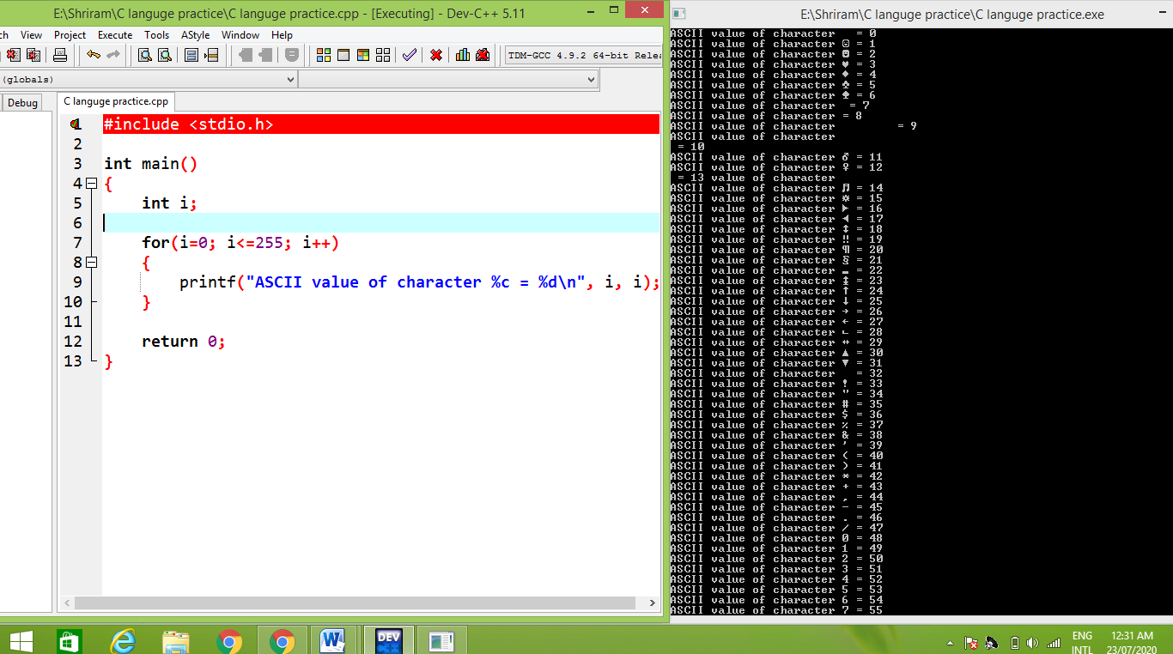

**9.** WAP to find power of a number (a^b).

**CODE:**

#include<stdio.h>

int main ( void )

{ int base, exponent, result = 1;

printf("\nEnter base: \n");

scanf("%d", &base);

printf("\nEnter exponent:\n ");

scanf("%d", &exponent);

int i = 1;

while(i <= exponent)

{result *= base;

i++; } printf ("\n%d^%d = %d\n", base, exponent, result);

return 0;

}

**OUTPUT:**

Enter Base : 15

Enter exponent: 10

15 ^ 10 = 1124772916

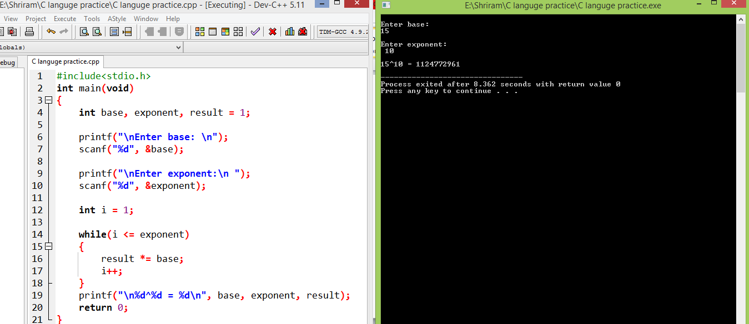

**10**. WAP to print prime numbers from 1 to 50.

**CODE:**

#include <stdio.h>

int main()

{

int num1, num2, flag_var, i, j;

printf("\nEnter two range(input integer numbers only):\n");

scanf("%d %d", &num1, &num2);

printf("\n Prime numbers from %d and %d are:\n", num1, num2);

for(i=num1+1; i<num2; ++i)

{

flag_var=0;

for(j=2; j<=i/2; ++j)

{

if(i%j==0)

{

flag_var=1;

break; }}

if(flag_var==0)

printf("%d\n",i);

}

return 0;

}

**OUTPUT:**

Enter two ranges (input integer numbers only): 1 to 50

Prime numbers from 1 and 50 are:

2

3

5

7

11

13

17

19

23

29

31

37

41

43

47

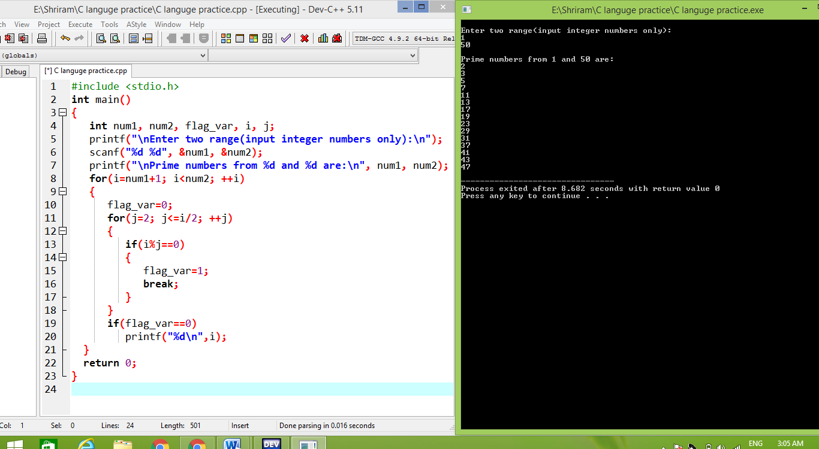

11. WAP using function to find sum of all digits in a number.

**CODE:**

#include <stdio.h>

int sum (int a);

int main( )

{

int num, result ;

printf("\nEnter the number:\n ");

scanf("%d", &num);

result = sum(num);

printf("\n Sum of digits in %d is %d\n", num, result);

return 0;

}

int sum (int num)

{

if (num != 0)

{

return (num % 10 + sum (num / 10));

}

else

{

return 0;

}

}

**OUTPUT:**

Enter the number:

15455

Sum of digits in 15455 is 20.

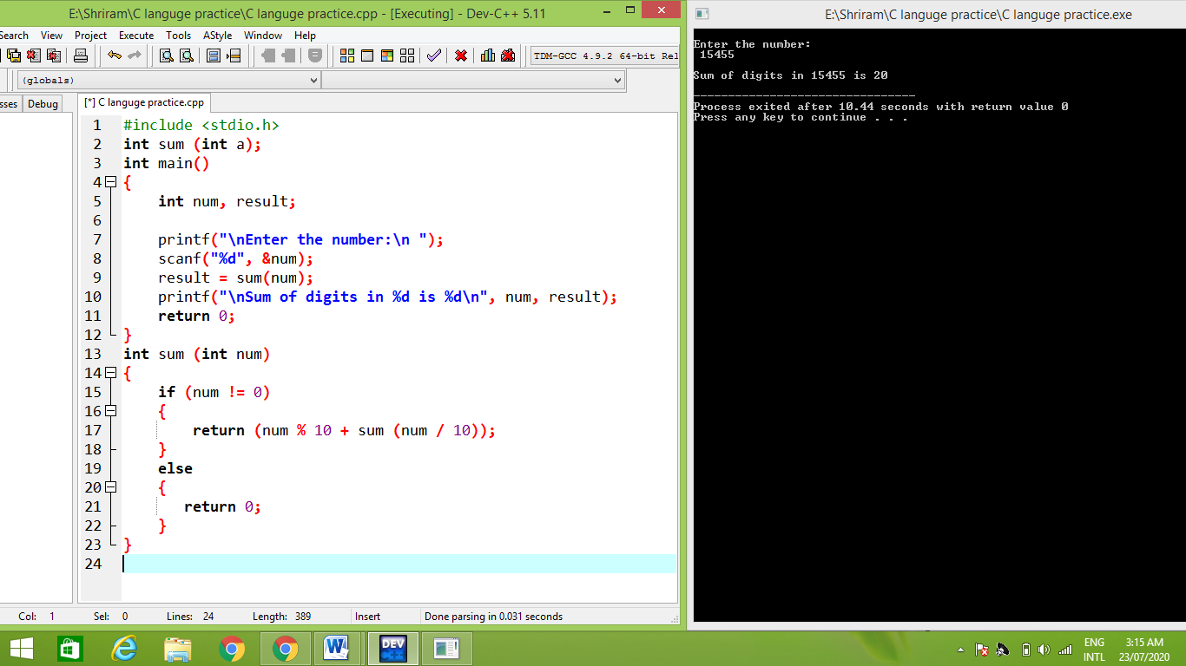

**12.** WAP using function to find factorial of a number.

**CODE:**

#include<stdio.h>

long int multiply Numbers(int n);

int main() {

int n;

printf("\n Enter a positive integer:\n ");

scanf("%d" ,&n);

printf("\n Factorial of %d = %ld\n", n, multiply Numbers(n));

return 0;

} long int multiply Numbers(int n) {

if (n>=1)

return n*multiply Numbers(n-1);

else

return 1;

}

**OUTPUT:**

Enter a positive integer:

4

Factorial of 4 = 24



**13.** WAP to swap two numbers.

**CODE:**

#include<stdio.h>

int main()

{

int a=10, b=20;

printf("\n Before swap a=%d b=%d \n ",a, b);

a=a+b;

b=a-b;

a=a-b;

printf("\n After swap a=%d b=%d \n ",a, b);

return 0;

}

OUTPUT:

Before swap a=10 b=20

After swap a=20 b=10

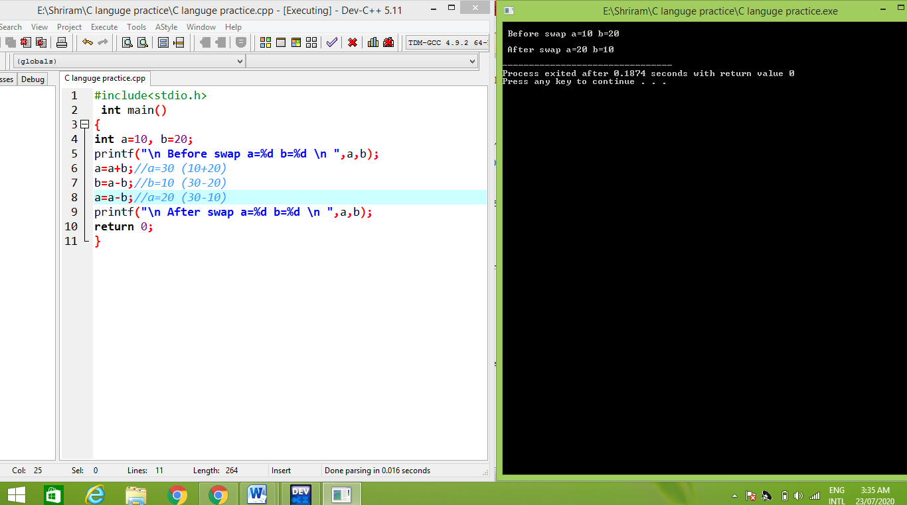

14. Take a number as input & Write a menu driven program for 1. Factorial 2.Prime or not.

**CODE:**

#include<stdio.h>

int main()

{

int c=0, num, res, n, flag=0, i;

while(c! =4)

{

printf("\n1. Factorial of a number \n2. Prime or not \n3. . Exit\n");

printf("\nEnter your choice:\n");

scanf("%d", &c);

switch(c)

{

case 1:

printf("\nEnter an integer: \n");

scanf("%d", &num);

n=num;

res=num;

while(num>1)

{

res = res*(num-1);

num = num-1;

}

printf("\n Factorial of %d is %d. \n\n", n, res);

break;

case 2:

printf("\nEnter an integer: \n");

scanf("%d", &num);

n=num;

for(i=2;i<=n/2;i++)

{

if(num%i==0)

{

flag=1;

break;

}

}

if(num==1)

printf("\n1 is neither prime nor composite\n");

else

{

if(flag==0)

printf("\n%d is Prime Number.\n\n", n);

else

printf("\n%d is not a Prime Number.\n\n", n);

}

break ;

case 3:

printf("\n Exit\n");

break;

}

}

}

**OUTPUT:**

1. Factorial of a number

2. Prime or not

3. Exit

Enter your choice:

1

Enter an integer:

4

Factorial of 4 is 24.

1. Factorial of a number

2. Prime or not

3. Exit

Enter your choice:

2

Enter an integer:

3

3 is a prime number.

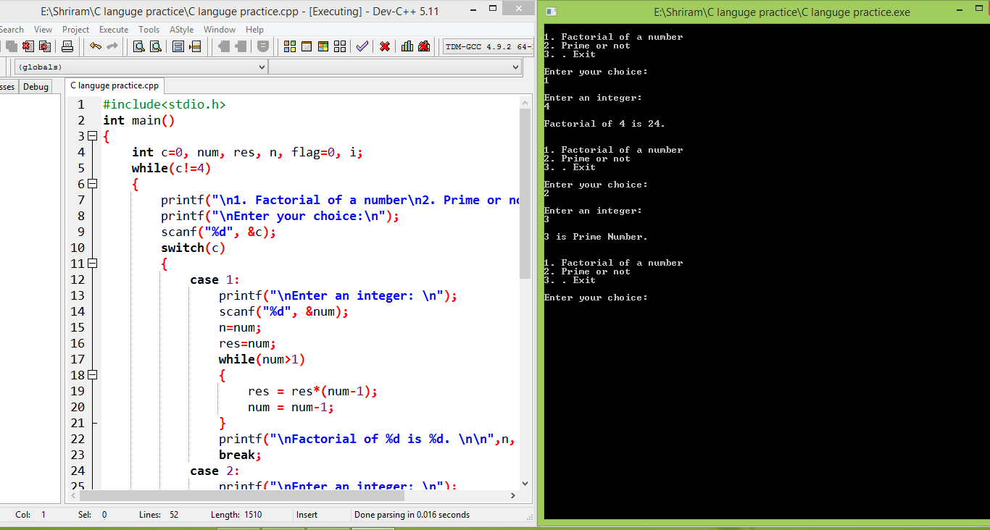

**15.** Write a menu driven program for operations on 2 numbers: 1. Swap 2. Power (a ^ b) 3. Max value.

**CODE:**

#include <stdio.h>

int main( )

{ int a,b,c=1;

int choice;

printf("\nEnter the value of a and b: ");

scanf("%d%d",&a,&b);

printf("\n");

printf("\n 1. Swap ");

printf("\n 2. (a ^ b");

printf("\n . Max Value");

printf("\n 4. Exit");

printf("\n");

do

{ printf("\n\nEnter choice ->");

scanf("%d", &choice);

switch (choice)

**{ Case** 1:

printf("\n Before swap a=%d b=%d \n ",a, b);

a=a+b;

b=a-b;

a=a-b;

printf("\n After swap a=%d b=%d \n ",a, b);

break;

**case 2:**

printf("\nEnter a: \n");

scanf("%d", &a);

printf("\nEnter :\n ");

scanf("%d", &b)

int i = 1;

while(i <= b)

{ c *= a;

i++; } printf ("\n%d^%d = %d\n", a, b, c);

break;

**case 3:**

printf("\n ");

if (a > b)

printf("Max number is ",a);

else if (a==b)

printf("both are equal");

else

printf("Max number is ",b)

break;

default:

printf("\n")

return 0; } }

While(choice<=5);

}

**OUTPUT:**

Enter the value of a and b:

3

5

1. Swap

2. (a ^ b)

3. Max Value

4. Exit

Enter choice ->

1

Before swap a=3 b=5

After swap a=5 b=3

Enter the choice

2

Enter a:

3

Enter b:

5

3 ^ 5 = 243

Enter choice ->

